# Overview

This document contains the necessary information to build the Aspen Sliding Joystick, including a customization guide, 3D printing guide, assembly guide, and instructions to test the finished joystick.

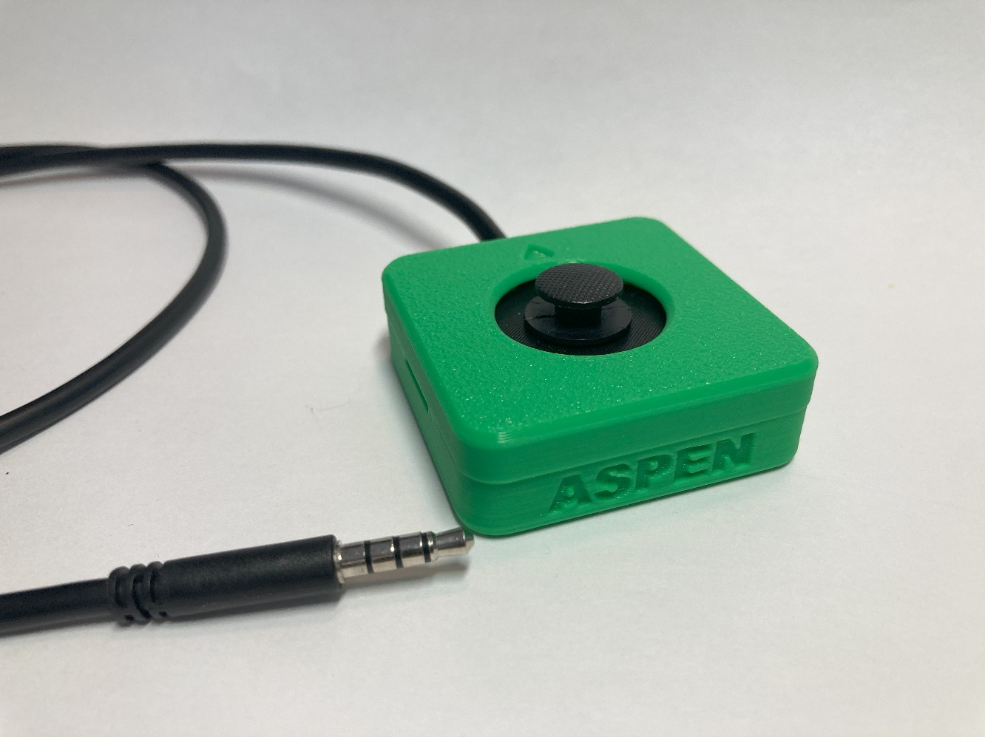

Contents

Overview 1

Maker To Do List 4

Items to Give to User 4

Customization Guide 5

Joystick 5

Toppers 5

Mounting 5

3D Printing Guide 6

3D Printing Summary 6

3D Printing Settings 6

Joystick Enclosure - REQUIRED 6

Toppers and Mount Adapters* - OPTIONAL 6

Post-Processing 7

Examples of Quality Prints 7

Assembly Guide 10

Required Components 10

Required Tools 10

Optional Tools 10

Required Personal Protective Equipment (PPE) 10

Joystick Assembly 11

Step 1: Solder Joystick to Breakout Board 11

Step 2: Prepare Audio Cable 11

Step 3: Identify Audio Cable Wires 12

Step 4: Wire the Joystick 12

Step 6: Check for Shorts 14

Step 7: Insert M3 Hex Nuts 15

Step 8: Insert Joystick Into Enclosure 15

Step 9: Route TRRS Cable 16

Step 10: Position Joystick Inner Disk 16

Step 11: Assemble Enclosure 17

Step 13: Joystick Assembly Complete 17

Testing 18

Testing using a Multimeter 18

Testing using an USB-HID Gamepad Interface Device 20

Optional – Mounting 21

Table Top Mounting – Non-Slip Pads 21

Table Top Mounting – Hook and Loop Fastener 21

Camera Mount 22

This list provides an overview of the steps required to build and deliver the device.

## Maker To Do List

* Read through the Maker Guide to become familiar with required components, tools, supplies, safety gear, and overall assembly steps.
* Ask the user if they would if they have a device to connect the joystick to.
  + [Xbox Adaptive Controller](https://www.xbox.com/en-CA/accessories/controllers/xbox-adaptive-controller)
  + [PlayStation Access Controller](https://www.playstation.com/en-ca/accessories/access-controller/)
  + [Forest Joystick Mouse Hub](https://github.com/makersmakingchange/Forest-Joystick-Mouse-Hub)
  + [Enabled Controller Mini](https://github.com/makersmakingchange/Enabled-Controller-Mini/tree/main)
  + [Enabled Controller](https://github.com/milador/Enabled-Controller)
  + Other Analog to USB joystick hub
* Ask the user if they would like any joystick toppers.
* Ask the user if they would like a specific mounting solution.
  + Tabletop
    - Hook and Loop Fasteners
    - Non slip material
  + Camera Mount Adapter
  + RAM Mount Adapter
* Talk to User about customization options (e.g., colour, any special requests, etc.).
* Order hardware components.
* 3D print all 3D printed components.
* Gather tools, supplies, and safety equipment.
* Assemble the device.
* Test device.
* Print “User Guide”

## Items to Give to User

* Assembled, tested device
* Any joystick toppers if requested.
* Any mount adapters if requested.
* “User Guide”

# Customization Guide

## Joystick

The enclosure can be printed in the user’s desired colour(s). Colour swaps can be done to further customize the joystick and make the forward arrow on the top stand out more.

## Toppers

3D printed joystick toppers can be added to the joystick. Current topper type include the small dome, medium dome, large dome, ring, and concave (shown left to right). These toppers can also be modified through the original design files.

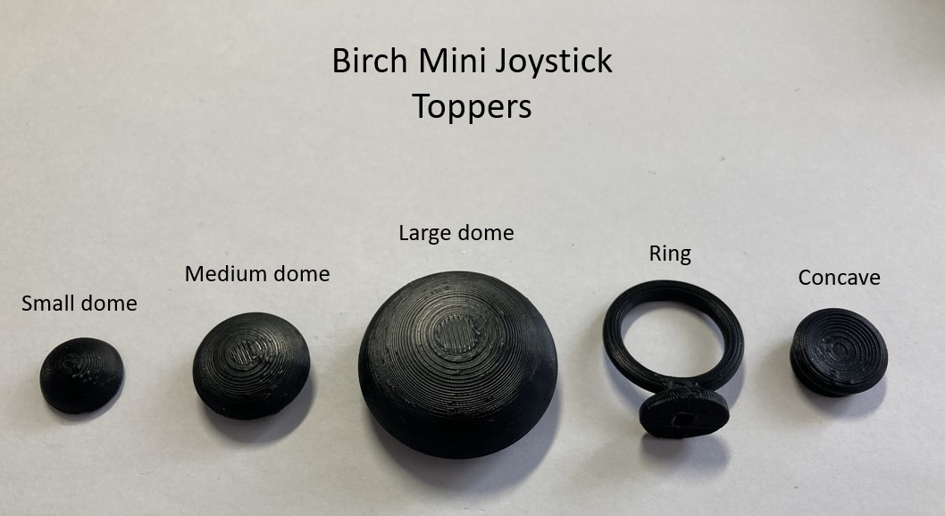

## Mounting

Mount adapters can be added for custom mounting solutions. Current mounting options include nonslip pads, hook and loop fastener, and a ¼-20 camera mount adapter.

# 3D Printing Guide

## 3D Printing Summary

|  |  |  |
| --- | --- | --- |
| **Metrics** | **Joystick Enclosure** | **All Toppers** |
| Total Print Time (min) | 1h34m | 1h28m |
| Total Number of Components | 3 | 5 |
| Typical Total Mass (g) | 13.2 | 9.7 |
| Typical Number of Print Setups | 1 | 1 |

## 3D Printing Settings

### Joystick Enclosure - REQUIRED

|  |  |  |  |  |  |  |  |
| --- | --- | --- | --- | --- | --- | --- | --- |
| **Print File Name** | **Qty** | **Total Print Time (hr:min)\*** | **Mass (g)** | **Infill (%)** | **Support (Y/N)** | **Layer Height/ Nozzle Diameter(mm)** | **Notes** |
| Aspen_Enclosure_ Bottom | 1 | 1:02 | 8.1 | 20 | N | 0.2/0.4 |  |
| Aspen_Enclosure_Top | 1 | 0:28 | 4.6 | 20 | N | 0.2/0.4 |  |
| Aspen_Inner_cover_disk | 1 | 0:04 | 0.5 | 20 | N | 0.2/0.4 |  |

### Toppers and Mount Adapters* - OPTIONAL

|  |  |  |  |  |  |  |  |
| --- | --- | --- | --- | --- | --- | --- | --- |
| **Print File Name** | **Qty** | **Total Print Time (hr:min)\*** | **Mass (g)** | **Infill (%)** | **Support (Y/N)** | **Layer Height/ Nozzle Diameter(mm)** | **Notes** |
| Joystick_Camera_ Mount_Adapter | 1 | 0:43 | 6.5 | 20 | Y | 0.2/0.4 |  |
| Joystick_RAM_B_Mount_ Adapter | 1 | 1:01 | 9.3 | 20 | Y | 0.2/0.4 |  |
| Sliding_Topper_Small_ dome | 1 | 0:08 | 0.6 | 20 | N | 0.2/0.4 |  |
| Sliding_Topper_Medium_ dome | 1 | 0:17 | 1.7 | 20 | Y | 0.2/0.4 |  |
| Sliding_Topper_Large_ dome | 1 | 0:37 | 4.9 | 20 | Y | 0.2/0.4 |  |
| Sliding_Topper_Ring | 1 | 0:16 | 1.5 | 20 | Y | 0.2/0.4 | Print with ring parallel to print bed |
| Sliding_Topper_Concave | 1 | 0:10 | 1.0 | 20 | N | 0.2/0.4 |  |

*Print times are based off of an Ender 3 S1 printer

## Post-Processing

* Remove any bumps or zits from the surface where the enclosure meets the lid.
* Remove any bumps or zits from both surfaces of the inner cover disk. If any binding occurs between the joystick and the inner cover disk when assembling, sand down this part.
* Remove any supports from camera mount or toppers if printed.

## Examples of Quality Prints

**Photos of Enclosure 3D Prints**

Enclosure Bottom

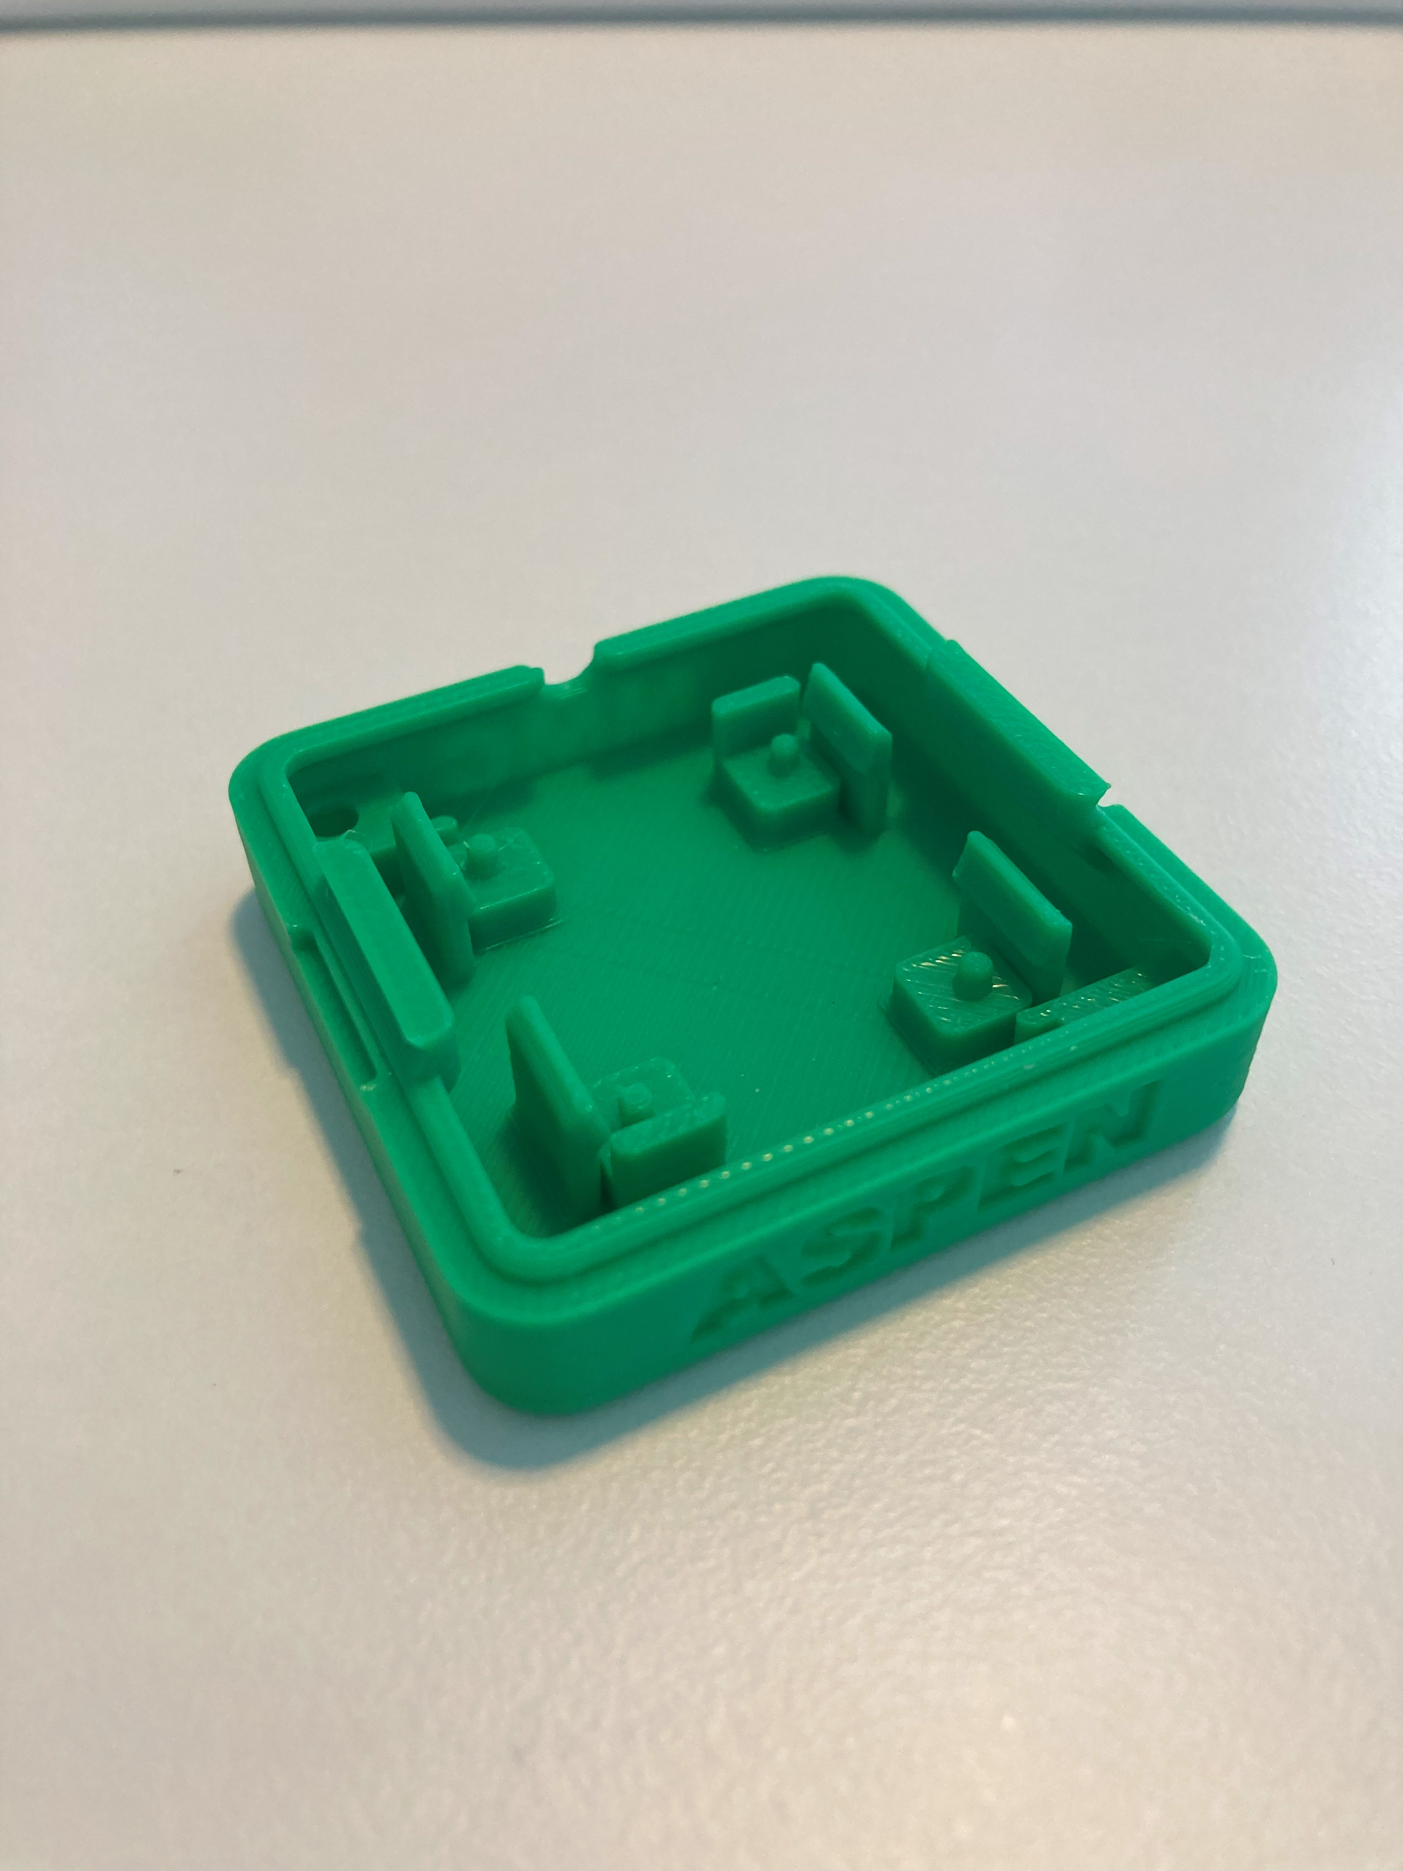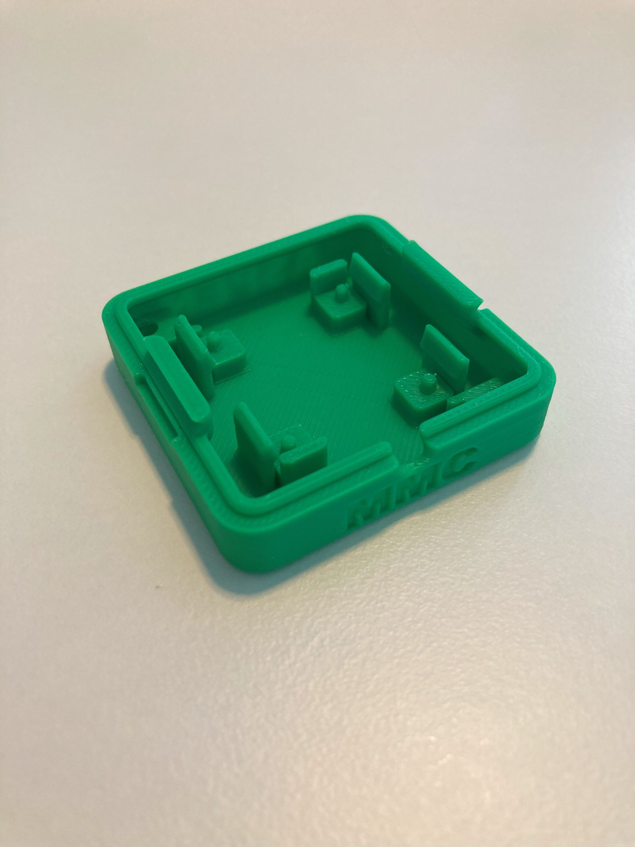

Enclosure Top

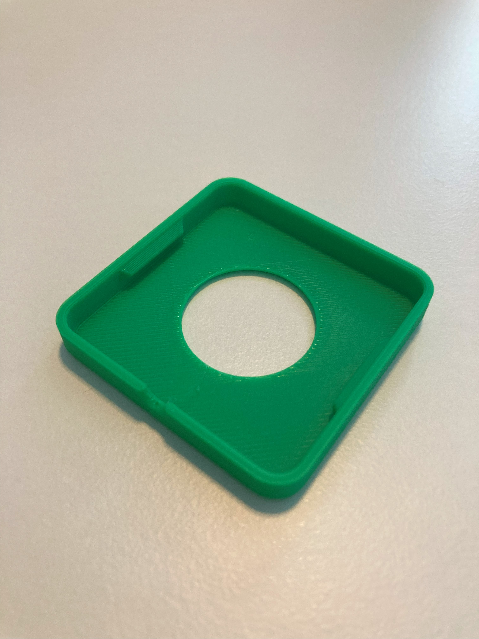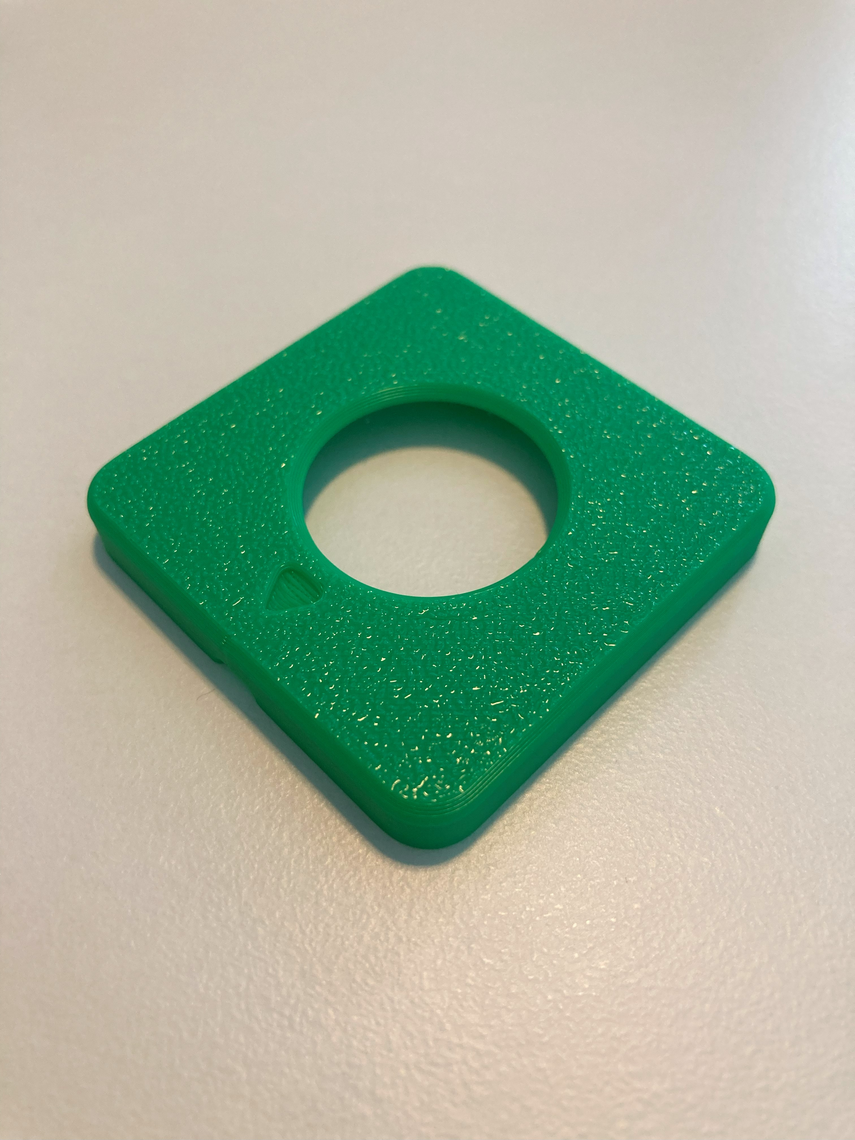

Inner Cover Disk

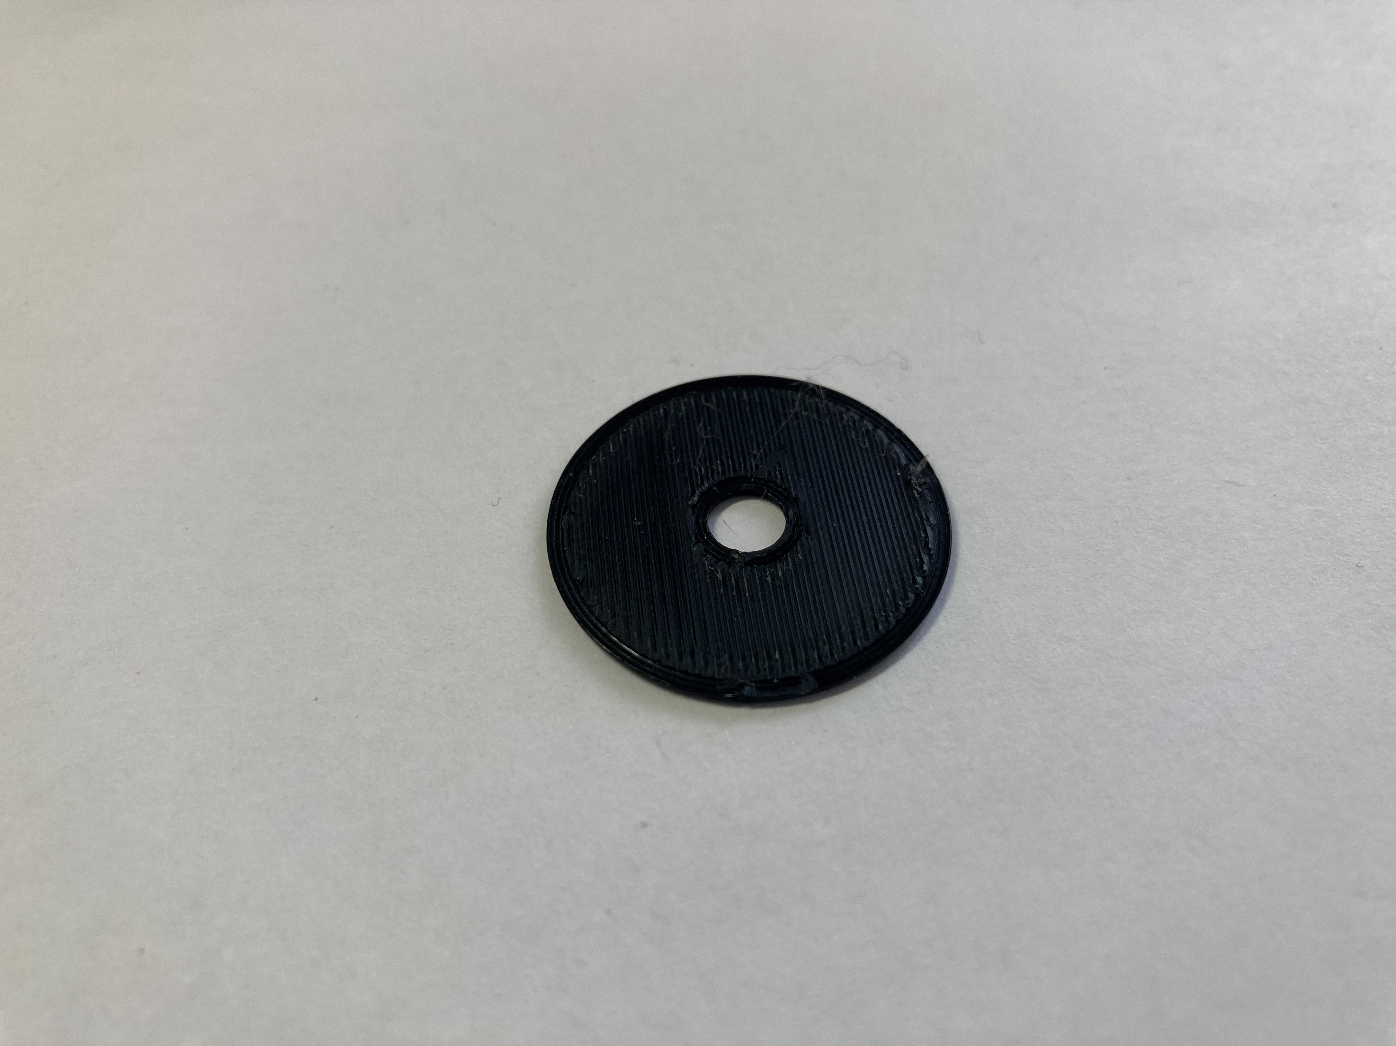

**Photos of Joystick Camera Mount Adapter 3D Prints**

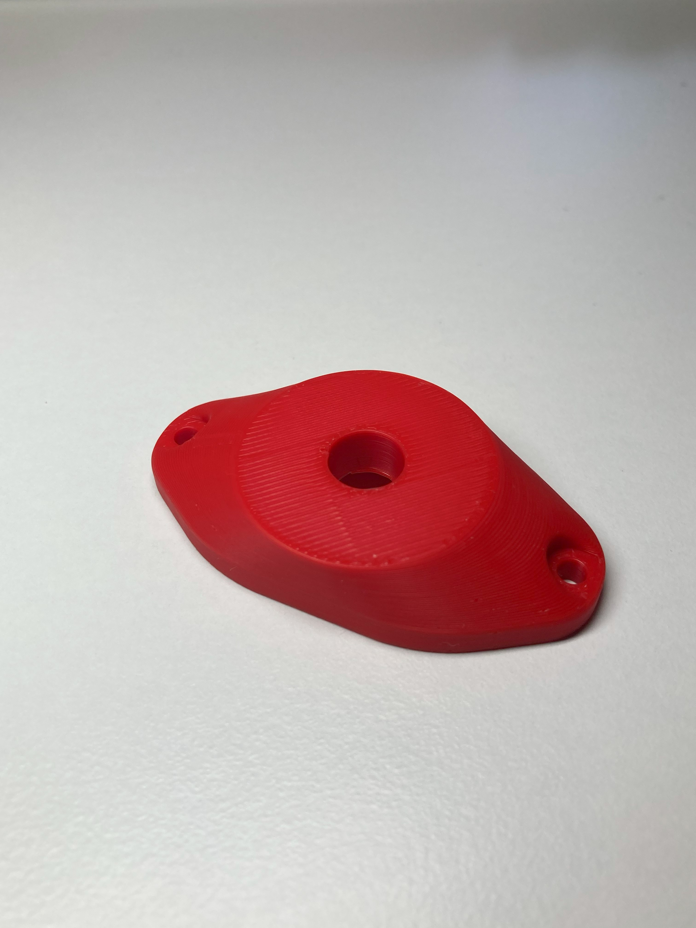 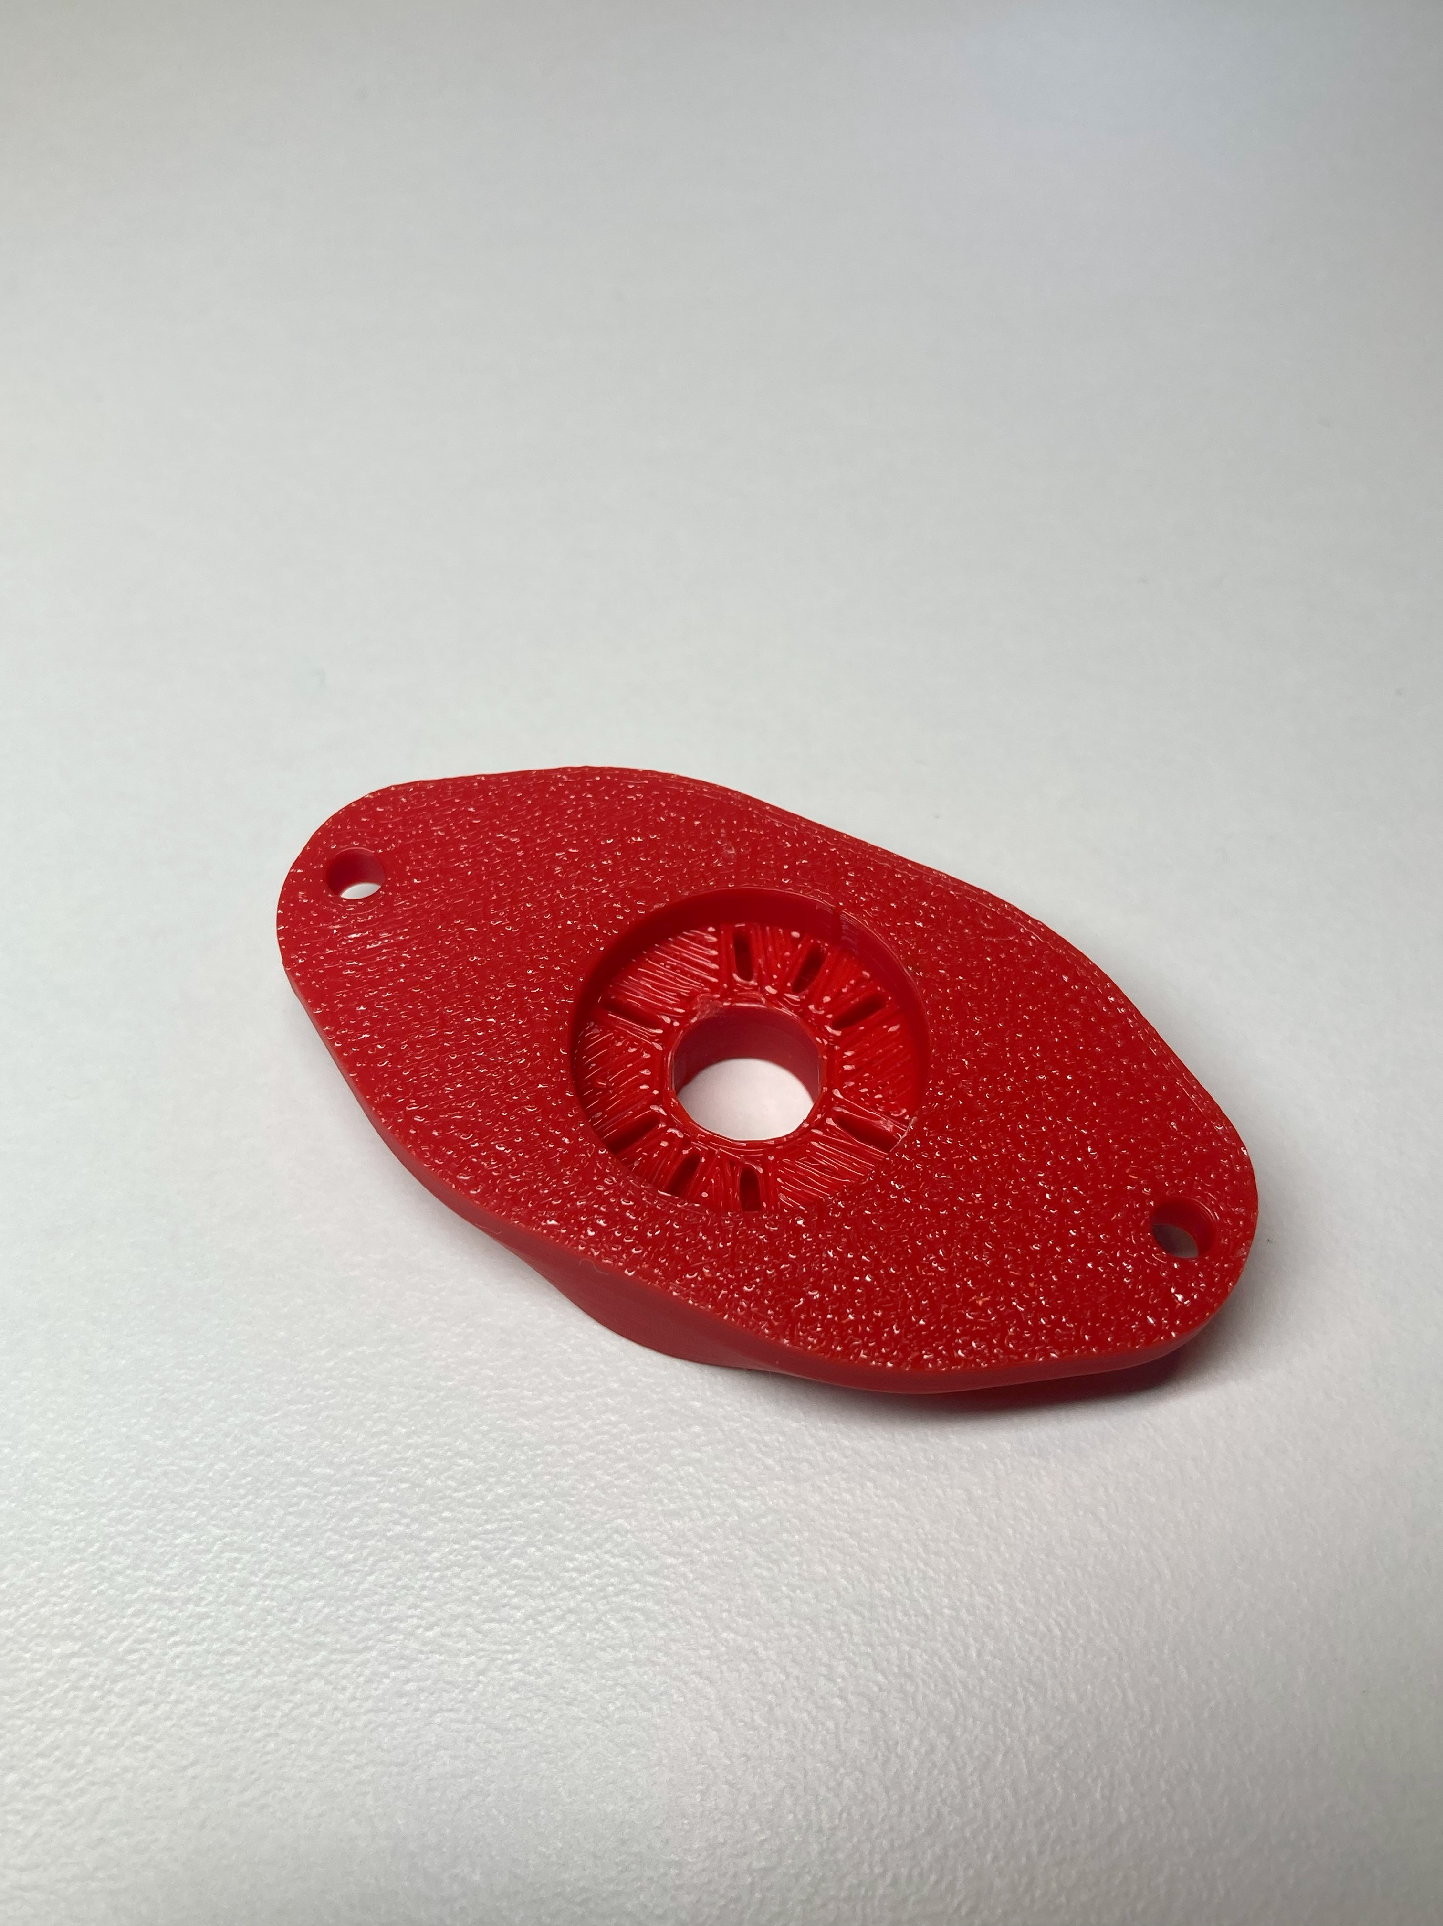

**Photos of RAM Mount Adapter 3D Prints**

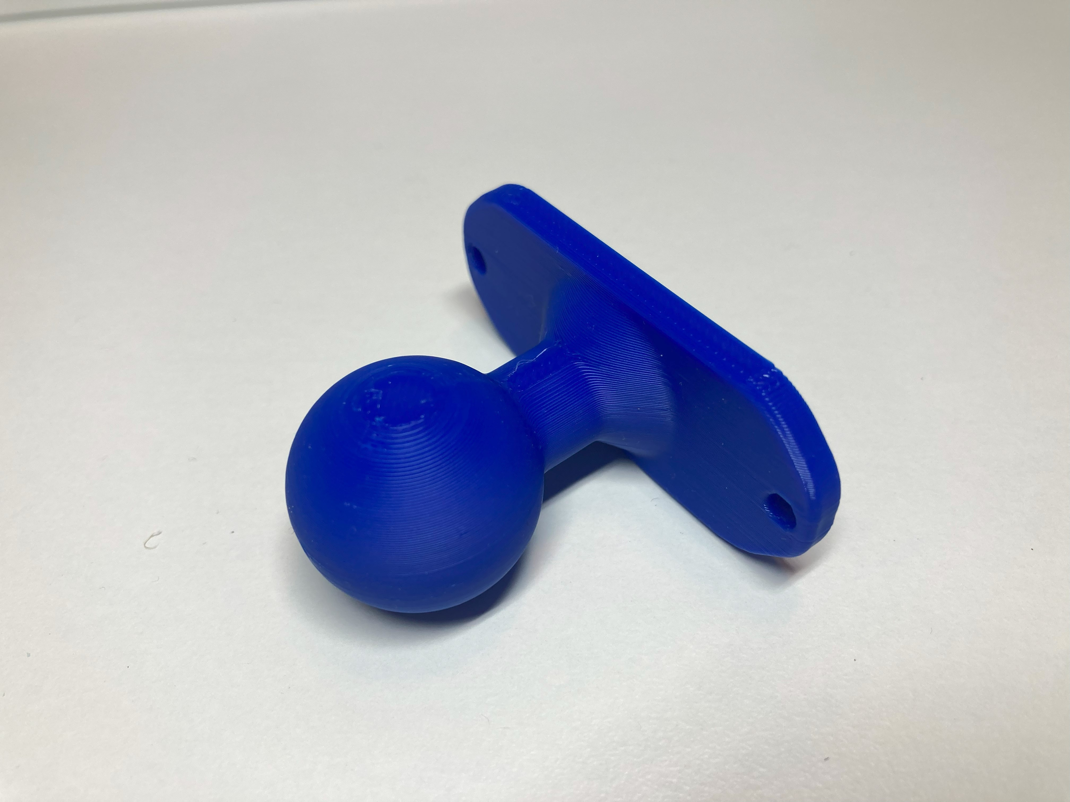 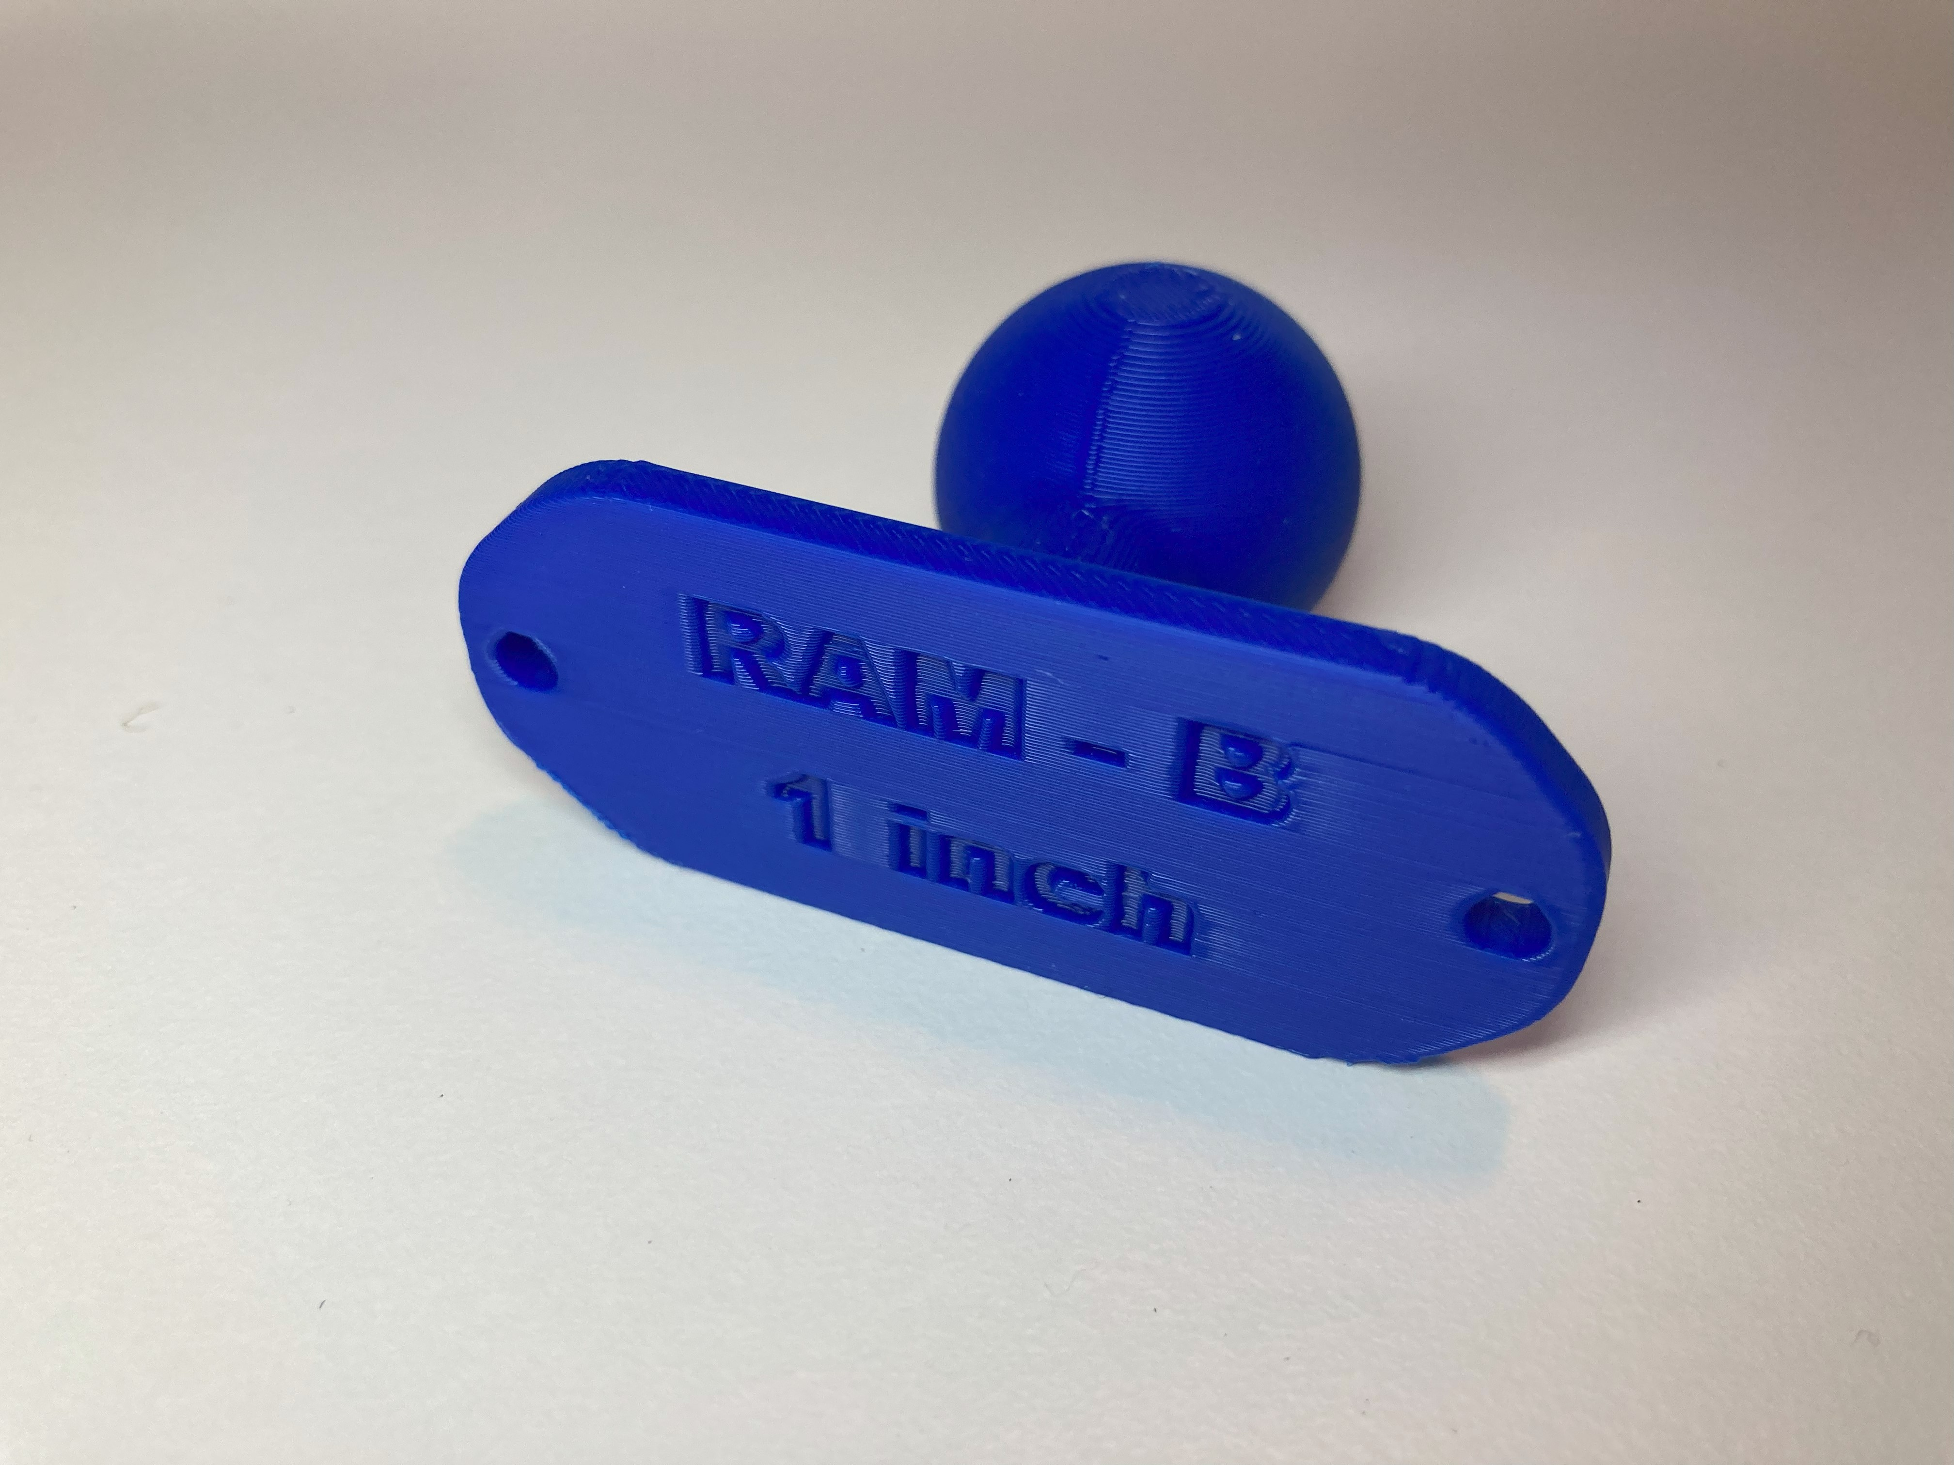

**Photos of Joystick Topper 3D Prints**

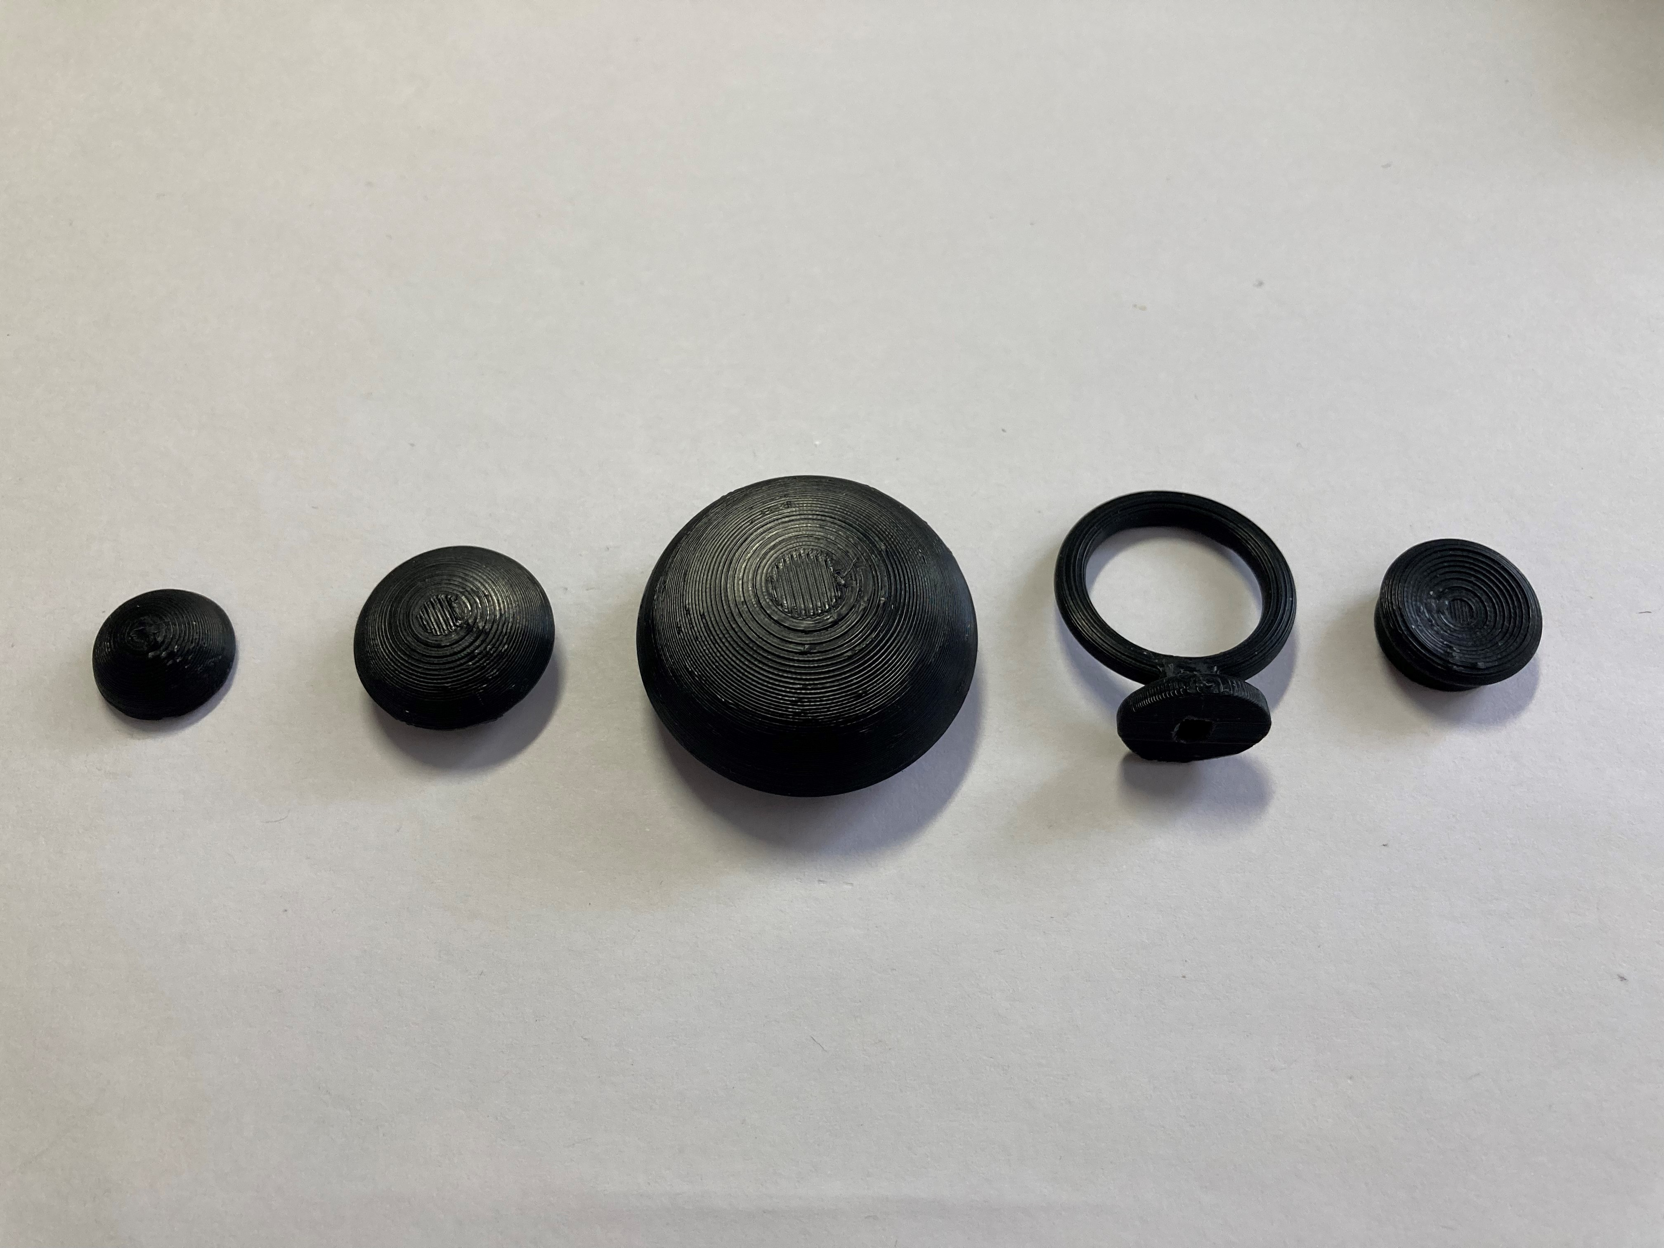

# Assembly Guide

## Required Components

|  |  |  |  |  |  |  |  |  |
| --- | --- | --- | --- | --- | --- | --- | --- | --- |
| **1** | Mini 2-Axis Analog Thumbstick | QTY 1 | **2** | Analog Mini Thumbstick Breakout Board | QTY 1 | **3** | TRRS Audio Cable | QTY 1 |
|  | | |  | | | A photo of the Digikey TRRS audio cable. | | |
| **4** | M3 Hex Nuts | QTY 2 | **5** | Aspen Inner Disk | QTY 1 | **6** | Aspen Enclosure Bottom | QTY 1 |
| A photo of two metal M3 hex nuts. | | | Small black 3D printed disk | | |  | | |
| **7** | Aspen Enclosure Top | QTY 1 |
|  | | |

## Required Tools

* Flush Cutters
* Wire Strippers
* Soldering Iron and Solder
* Multimeter (with continuity testing capabilities)

## Optional Tools

* Tweezers

## Required Personal Protective Equipment (PPE)

* Safety Goggles

## 

## Joystick Assembly

### Step 1: Solder Joystick to Breakout Board

|  |  |
| --- | --- |
| Insert the mini 2-axis analog thumbstick into the breakout board.  Solder the 6 pins, shown circled in red. | Close up of the joystick unit on the breakout board intended for use with standard headers. Close up of the bottom of the joystick breakout board. The pads where the joystick pins are circled in red.Close up of the bottom of the joystick breakout board. The pads where the joystick pins have been soldered and are circled in red. |

### Step 2: Prepare Audio Cable

|  |  |
| --- | --- |
| If you are using the pre-prepared TRRS cable from DigiKey, pictured in the component list, you can skip this step.  If using a different cable, prepare the wires for soldering:   * Cut the TRRS cable to length (typically 1 m). * Strip off approximately 2 cm of the outer insulation. * Then, separate the 4 individual inner wires. If there are three insulated wires plus copper strands, twist these copper strands together to be one of your wires. If there are 4 insulated wires plus loose copper stranded wires, cut off these copper wires. * Strip off approximately 0.5 cm of insulation from the inner wires. * For each inner wire, twist the inner strands together | Cable with 4 smaller inner cables with insulation and small uninsulated wires to one side.  Cable with 4 smaller insulated wires coming out. The insulation has been stripped off of the ends. |

### Step 3: Identify Audio Cable Wires

|  |  |
| --- | --- |
| If using the pre-prepared DigiKey cable, you can skip this step.  If using a different cable, you need to identify which wires correspond to which parts of the plug. Use a multimeter or other continuity tester to confirm. Follow this [guide for checking continuity](https://www.youtube.com/watch?v=T4p8UQZqh5U) to determine which wire corresponds to the Sleeve, Ring 1, Ring 2, and Tip of the TRRS cable plug. You can use the table below to write the corresponding colours for your cable. | A qr code on a white background linking to a guide for checking continuity. |

|  |  |  |
| --- | --- | --- |
| TRRS Plug | DigiKey TRRS cable | Your TRRS cable |
| Sleeve | Black |  |
| Ring 2 | Green |  |
| Ring 1 | White |  |
| Tip | Red |  |

### Step 4: Wire the Joystick

Wiring the joystick will follow the diagram below and will be broken down into multiple steps.

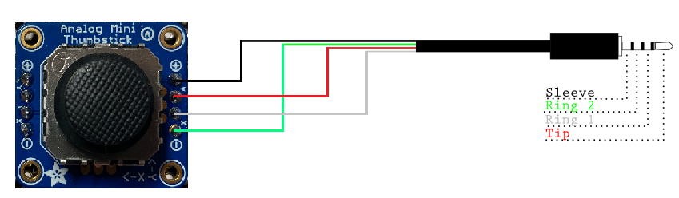

Figure 1. Joystick Wiring Guide. Image Remixed from Sparkfun, released under a CC BY 2.0 license.

Table 1: Aspen Wiring

|  |  |  |  |
| --- | --- | --- | --- |
| Joystick Breakout Board | CONNECTION | Digikey TRRS Cable | Your TRRS Cable |
| + | Sleeve (S) | Black |  |
| Y | Tip (T) | Red |  |
| X | Ring 1 (R1) | White |  |
| - | Ring 2 (R2) | Green |  |

#### Step 4A: Identify the Correct Solder Pads

|  |  |
| --- | --- |
| With the joystick breakout board aligned such that the words are at the top and facing you, the pins to solder to are on the right, closest to the text with the “X” and “Y” next to small arrows.  Do not solder to the pins on the left. | Picture of joystick on breakout board. The words on the breakout board are oriented at the top. There is a white oval circling the solder pads on the right and a red "X" over the solder pads on the left. |

#### Step 4B: Solder TRRS Sleeve to + Pad

|  |  |
| --- | --- |
| Insert the TRRS audio cable **sleeve** wire (black or copper) into the **+ Pad** on right side of the joystick breakout board, with the wire going in from the bottom of the board to the top.  Solder the wire to the pad on the top of the board. | Joystick breakout board showing the copper wire soldered to the + pin. |

#### Step 4C: Solder TRRS Tip to Y Pad

|  |  |
| --- | --- |
| Insert the TRRS audio cable **tip** wire (red) into the **Y Pad** on right side of on the joystick breakout board, with the wire going in from the bottom of the board to the top.  Solder the wire to the pad on the top of the board. | Joystick breakout board showing the red wire soldered to the Y pin. |

#### Step 4D: Solder TRRS R1 to X Pad

|  |  |
| --- | --- |
| Insert the TRRS audio cable **Ring 1** wire (white) into the **X Pad** on right side of on the joystick breakout board, with the wire going in from the bottom of the board to the top.  Solder the wire to the pad on the top of the board. | Joystick breakout board showing the white wire soldered to the X pin. |

#### Step 4E: Solder TRRS R2 to - Pad

|  |  |
| --- | --- |
| Insert the TRRS audio cable **Ring 2** wire (green) into the **- Pad** on right side of on the joystick breakout board, with the wire going in from the bottom of the board to the top.  Solder the wire to the pad on the top of the board. | Joystick breakout board showing the green wire soldered to the - pin. |

### Step 6: Check for Shorts

|  |  |
| --- | --- |
| Inspect the board and check that none of the connections are shorted.  There should be no bridges/connections between adjacent pins.  If you have a multimeter, you can use it to double check continuity.  If the solder is connecting anything it should not, use the soldering iron and some extra wire, solder wick, or a desoldering tool to remove solder from that area. | A warning icon. |

### Step 7: Insert M3 Hex Nuts

|  |
| --- |
| Take the enclosure bottom and insert the M3 nuts into the slots as shown. You may require a tool such as needle-nosed pliers or a screwdriver to push the nuts into place. |
| A photo of the nuts being inserted into the enclosure bottom.A photo of the nuts inserted into the enclosure bottom. |

### Step 8: Insert Joystick Into Enclosure

|  |  |
| --- | --- |
| With the enclosure aligned such that the cable goes out away from you, and with the joystick aligned such that the text “Analog Mini Joystick” is to the right, press down on the joystick to snap it into place onto the small mounting posts. | Soldered joystick inserted into the bottom of the enclosure. |

### Step 9: Route TRRS Cable

|  |  |
| --- | --- |
| As shown in the photo, route the cable to the side of the enclosure, between the joystick snap fits and the edge of the enclosure, and then out the hole at the back of the enclosure. You may need to push the cable down to get it past the enclosure snap fit. | Inside of the joystick showing the joystick installed with the cable going around the outside of the enclosure. |

### Step 10: Position Joystick Inner Disk

|  |  |
| --- | --- |
| Remove the joystick topper.  Place the 3D printed inner disk on the joystick, around the joystick post.  Replace joystick topper. | Joystick breakout board without joystick topper Joystick with inner disk placed on joystick post. Joystick with inner disk and joystick topper. |

### Step 11: Assemble Enclosure

|  |  |
| --- | --- |
| Take the enclosure top, and with the cable indent away from you, aligned with the cable exit, place the top on the enclosure bottom and press down to snap into place. | A hand is placing the joystick enclosure top onto the enclosure bottom.  Assembled joystick. |

### Step 13: Joystick Assembly Complete

|  |  |
| --- | --- |
| The joystick assembly is now complete. | Completed Aspen joystick. |

## Testing

Now that you have your completed Aspen Joystick, you must test to make sure it is wired and assembled correctly. This can be done with a multimeter, or by plugging the joystick into one of the following: Forest Hub, Xbox Adaptive Controller (XAC), PlayStation Access Controller, Enabled Controller Mini, Enabled Controller, or other USB-HID controller that accepts the input of an analog joystick and connecting to a computer.

### Testing using a Multimeter

A multimeter can be used to test if the wires are connected and soldered correctly. It is most important to ensure that there is no short circuit between the Sleeve (Ground) and Tip (Voltage), as this can damage the host device. It can be tricky to place the probes and move the joystick, so tape, or a second person can be helpful here.

**Note:** The intended joystick for this build has two 10 KΩ potentiometers, but some joysticks use 5 KΩ potentiometers, which will result in the expected multimeter readings to be halved

#### Test 1: Testing for Short Circuits

|  |  |
| --- | --- |
| 1. Set the multimeter to measure resistance in the 1-10 KΩ range. 2. Hold the tip of the red probe of the multimeter to the Sleeve (Voltage) of the TRRS cable. 3. Hold the tip of the black probe of the multimeter to Ring 2 (Ground) on the TRRS cable. 4. Confirm that the resistance is between 4 – 6 KΩ.    1. Between 4 – 6 KΩ: No shorts. Proceed to next test.    2. Less than 50 Ω: There is a short circuit between a Ground and Voltage pin. This must be fixed to prevent damaging a host device. Open the joystick and review/fix your soldering joints.    3. Other values: There is a wiring problem. Open the joystick and review/fix your soldering joints. |  |

If you have no short circuits, you can move on to testing the joystick directions. This can be done with either the multimeter, or with a USB-HID gamepad that accepts an analog joystick.

#### Test 2: Testing Vertical Joystick Axis

|  |  |
| --- | --- |
| 1. Hold the tip of the red probe of the multimeter to the Sleeve (Voltage) of the TRRS cable. 2. Hold the tip of the black probe to Ring 1 (Y-axis) on the TRRS cable. 3. While holding the multimeter probes in place, move the joystick fully in the UP ↑ direction.    1. You may require a second person to hold the probes in place or move the joystick.    2. Otherwise, the joystick can be held in place with some tape to leave your hands free to hold the multimeter probes in place. 4. Read the resistance on the multimeter:    1. Less than .10 KΩ: The Y-axis potentiometer is wired correctly.    2. Otherwise, review the wiring diagram and ensure your wiring matches. 5. Release the joystick back to neutral position. |  |

#### Test 3: Testing Horizontal Joystick Axis

|  |  |
| --- | --- |
| 1. Hold the tip of the red probe of the multimeter to the Sleeve (Voltage) of the TRRS cable. 2. Hold the tip of the black probe to Tip (X-axis) of the TRRS cable. 3. While holding the multimeter probes in place, move the joystick fully in the RIGHT → direction.    1. You may require a second person to hold the probes in place or move the joystick.    2. Otherwise, the joystick can be held in place with some tape to leave your hands free to hold the multimeter probes in place. 4. Read the resistance on the multimeter.    1. Less than .10 KΩ: The X-axis potentiometer is wired correctly.    2. Otherwise, review the wiring diagram and ensure your wiring matches. 5. Release the joystick back to neutral position. |  |

#### Troubleshooting

If tests 2 or 3 fail, here are the likely scenarios to address.

##### Test 2 Fail

If the multimeter reading increases instead of decreasing when moving the joystick from the neutral position to the UP direction, then the Voltage and Ground pins are opposite and need to be swapped.

If the multimeter reading does not change, then the X and Y axis pins are opposite and need to be swapped.

##### Test 3 fail

If the multimeter reading instead of decreasing when moving the joystick from the neutral position the RIGHT direction, then the Voltage and Ground pins are opposite and need to be swapped.

If the multimeter reading does not change, then the X and Y axis pins are opposite and need to be swapped.

### Testing using an USB-HID Gamepad Interface Device

Before plugging the joystick into a USB-HID Gamepad Interface Device, ensure that there is no short circuit between the Tip and the Sleeve.

1. Plug the joystick into the analog joystick input for the host device.
   1. X1 or X2 on an Xbox Adaptive Controller.
2. Plug the host device into a computer.
3. If using Windows, open “Set up USB Game Controllers” from the Control Panel. You can find this by searching your computer in the search bar next to the Windows icon.
   1. If using a Mac, use <https://hardwaretester.com/gamepad>
4. Select the host device from the list of controllers and go to “Properties”.
5. Move your joystick and observe the movement of the cross hatch in the “Axes” window. Ensure it moves in the proper directions when you move the joystick (the arrow points in the up direction). If not, open the joystick and check your connections.

## Optional – Mounting

### Table Top Mounting – Non-Slip Pads

|  |  |
| --- | --- |
| If using the joystick on a tabletop, and height of the joystick is not a concern, nonslip pads can be added in each of the four corners on the bottom, as shown. |  |

### Table Top Mounting – Hook and Loop Fastener

|  |  |
| --- | --- |
| If using the joystick on a tabletop or other surface with hook and loop fasteners, such as Velcro, stick the hook side (rough side) to the joystick and the loop side (soft side) to the surface to mount to. | Bottom of the joystick with hook and loop fastener attached to the bottom. The hook side is shown stuck to the joystick. |

### Camera Mount

To mount the joystick on a camera mount, the optional Joystick Camera Mount Adapter can be used.

|  |  |
| --- | --- |
| Step 1: Prepare and Orient 3D Print Flip the camera mount adapter around to reveal the recess with small slots.  Ensure all supports are removed from the 3D print. | Blue 3D printed part for the camera mount adapter. There are two holes on the sides and one hole in the middle with small slots around it. |

|  |  |
| --- | --- |
| Step 2: Insert Tee Nut Insert the tee nut, lining up the barbs with the small slots in the 3D print. | Blue 3D printed part for the camera mount adapter, with a tee nut sitting inside of it, not fully inserted. |

|  |  |
| --- | --- |
| Step 3: Screw in Bolt Flip the part around and screw in a ¼-20 hex bolt. | Blue 3D printed part for the camera mount adapter, with a hex bolt being screwed into it. There is a white arrow showing to screw in the hex bolt clockwise. |

|  |  |
| --- | --- |
| Step 4: Tighten Bolt Tighten the bolt until the tee nut is seated down as far as possible.  (Alternatively, if you do not have acces to a bolt, the tee nut may be press fit as long as it sits flush with the 3D print.) | Top of the camera mount adapter, with a hex bolt fully screwed into it. There is a white arrow showing to screw in the hex bolt clockwise. Bottom of the camera mount adapter, showing a tee nut fully installed into the 3D print, and sitting flush. There are two arrows pointing down to indicate that the tee nut is all the way down. |

|  |  |
| --- | --- |
| Step 5: Attach to Joystick Using 2 M3 screws, screw the camera mount adapter to the bottom of the joystick in the two middle holes. |  |